## ELEC 3300 Project Proposal – Auto Drawing Machine

Group 50

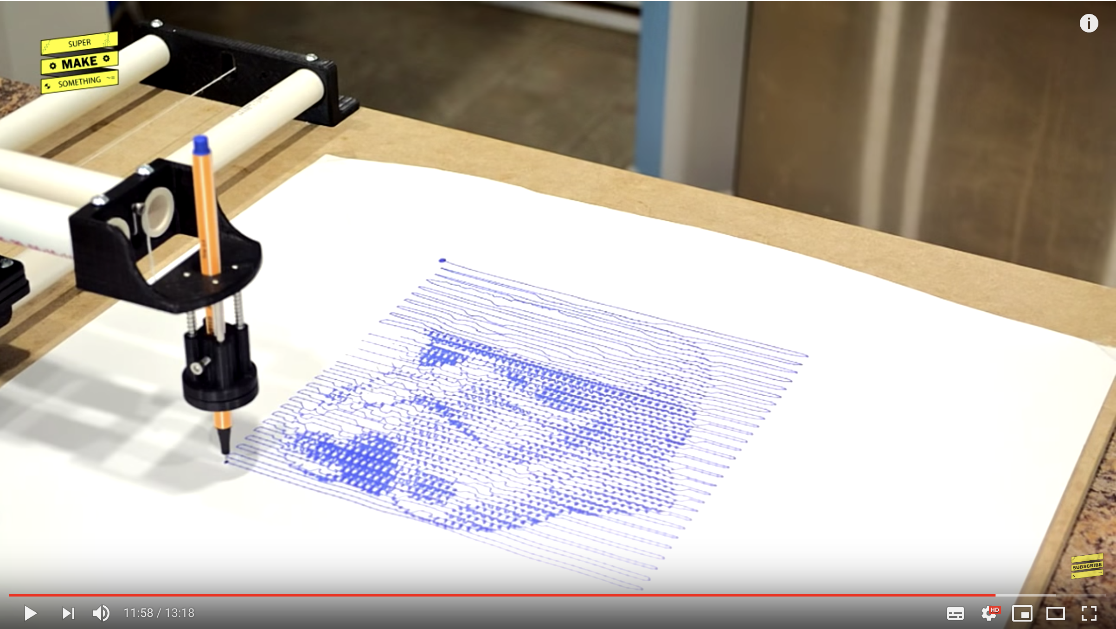

Motivation: I got the project idea from a YouTube video as shown above drawing a well-known mask in Star War. It is originally an Arduino project, so I’d like to reimplement it in STM32 and possibly add more feature.

Project Description:

The main structure of this drawing machine is two slides driven by stepper motor, which can let the pen freely move on the paper.

Some more features may be added like:

1. Changing the color of pen by spinning to choose from different pens
2. Send drawing picture from computer to STM32 by blue tooth.
3. Adding a camera so that it can take a portrait photo of one person and send the data to computer to plan the moving route and finally let the machine draw a portrait of that person.

Input (from camera to computer): RGB picture

Input (from computer to CPU): path that the pen needs to go

Output: the pen goes the way it is commanded to do so

Peripherals connections to the microcontroller:

Bluetooth, camera, 2 stepper motor

Role of the microcontroller:

Data communication

Controller of the stepper motor

Potential Difficulties:

1. The driver of stepper motor (Nema 17) need to be configured by myself.
2. The algorithm for deciding the moving route is not easy to design.
3. The overall mechanical structure design is a hard task for CPEG students.

Additions: GRBL is an open source, embedded, high performance g-code-parser and CNC milling controller which can be directly used to control the stepper motor to draw complicated graphs.

Here is a 3D Model online that is similar to my idea:

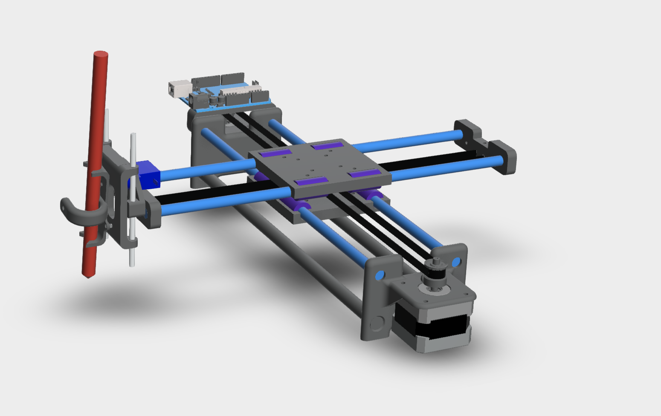

Material List:

Bought from Taobao:

Bluetooth: HC-05

<https://detail.tmall.com/item.htm?spm=a220m.1000858.1000725.4.3a0134137aMObT&id=41281471872&skuId=4087868706729&areaId=420100&user_id=2207691322&cat_id=2&is_b=1&rn=6aaa43d1993d2567ba4cf61bbe651b4f>

Step motor * 2: 42BYGH34 (with control plant)

<https://detail.tmall.com/item.htm?spm=a220m.1000858.1000725.2.68b93502h75Z4b&id=549001804876&areaId=420100&user_id=2207691322&cat_id=2&is_b=1&rn=53d1b0efc5c5b97dde7c2fe9a1f305d7>

Mainboard(STM32f103 with OV7725 and DAP and 3.2 inch LCD screen ): <https://detail.tmall.com/item.htm?spm=a220m.1000858.1000725.1.7d7853399SN7CX&id=574249692992&skuId=3761638092970&areaId=420100&user_id=738263294&cat_id=2&is_b=1&rn=b533d90f62a57978c3355a5bc6c63ac9>

1 micro servo SG90 (plus a 250mm cable extender)

<https://detail.tmall.com/item.htm?spm=a230r.1.14.1.afb553fbFZyhRl&id=41248626148&cm_id=140105335569ed55e27b&abbucket=15>

Others (maybe purchased in SZ):

4 8mm smooth rods (two 400mm-long and two 320mm-long)

<https://detail.tmall.com/item.htm?spm=a1z10.3-b.w4011-15876380394.15.3dc75bedGMw5Hr&id=561087554854&rn=8b8204df1f82d5e40039ef40205403dd&skuId=3678438163569>

8 LM8UU

<https://detail.tmall.com/item.htm?spm=a230r.1.14.6.6c421366X4FEKF&id=544276519074&cm_id=140105335569ed55e27b&abbucket=15&skuId=3442639930996>

10 F623ZZ bearings

<https://detail.tmall.com/item.htm?spm=a230r.1.14.11.6a8d7666Whu7ne&id=571496631674&cm_id=140105335569ed55e27b&abbucket=15&skuId=3866064251320>

1 GT2 belt ( 1.4 meters long )

<https://shop105849882.taobao.com/search.htm?q=GT2&s_from=newHeader&ssid=s5-e&search_type=item&sourceId=tb.item>

2 20-tooth GT2 pulleys

内径5mm

一家店

2 4mm OD, 100mm-long carbon fiber tubes

<https://item.taobao.com/item.htm?spm=2013.1.0.0.1a4348cb6K4oK7&id=18573517420>

2 M10 threaded rods (400mm-long each)

<https://detail.tmall.com/item.htm?spm=a230r.1.14.9.fccc1ed2Ibfd78&id=569925662540&cm_id=140105335569ed55e27b&abbucket=15&skuId=3832228711391>

下面的都问一下这家有没有

8 M10 nuts

8 30mm M3 screws with nuts

8 6mm M3 screws

4 16mm M3 screws with nuts

4 M3 washers

2 15mm M3 screws